**Musadique Hussain**

•

**Address:**

Magsi House Bypass town, Moro, 72002 Sindh Pakistan

•

**Email address:**

**Phone number:**

(+92) 3023093624

•

**LinkedIn:**

[(48)](https://www.linkedin.com/in/musadique-hussain-2069091b5/)

[Musadique Hussain | LinkedI](https://www.linkedin.com/in/musadique-hussain-2069091b5/)n

[n](https://www.linkedin.com/in/musadique-hussain-2069091b5/)

•

**Gender:**

Male

**Date of birth:**

02

/07/2002

**Nationality:**

Pakistani

**ABOUT ME**

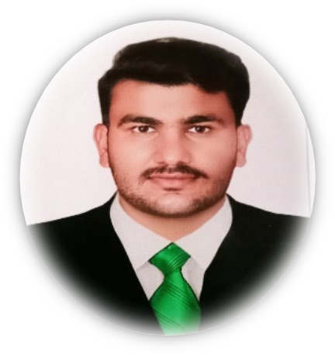

I am a computer systems engineer and learn data science skills looking for a position that will allow me to grow and learn new abilities in a fun and rigorous work environment. I am a dedicated and hardworking man who likes solving difficulties.

**EDUCATIONANDTRAINIG**

# [ 2019 – 2023 ] Bachelor - Computer Systems Engineering

***Mehran University of Engineering & Technology, Jamshoro, Pakistan*** <https://www.muet.edu.pk/>

[ 2017 – 2019 ] **Intermediate**

***Govt Mehran Degree College Moro, Sindh, Pakistan***

**Final grade:** A1, Percentage 81.2%

[ 2015 – 2017 ] **Intermediate**

***Govt Boy High School Deparja, Sindh, Pakistan***

**Final grade:** A1, Percentage 81%

# LANGUAGE SKILLS

**Mother tongue(s):** Sindhi,

**Other language(s):** English, Urdu, Seraiki

# DIGITAL COMPETENCE

**Courses:**

Big data Analysis, Web Design

**Programming Languages**

C/C++, Python, MATLAB, Java, HTML and CSS

**Software Packages**

MS-Office365, Jupyter Notebook, Latex, VS-Code, PyCharm, etc

**Operating Systems**

MS WINDOWS, LINUX, DOS, MAC, Android.

**PROJECTS**

Traffic Light System on Arduino

Website For Pizza House on Bootstrap

ATM System

Wall Clock on Computer graphics